**Benin country profile**

Published

29 April 2019

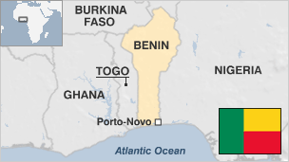

**Benin, formerly known as Dahomey, is one of Africa's most stable democracies.**

Benin's shore includes what used to be known as the Slave Coast, the departure point for captives to be shipped across the Atlantic.

Elements of the culture and religion brought by slaves from the area are still present in the Americas, including voodoo - which has made a comeback in Benin and is even celebrated at the country's annual Voodoo Day.

On the economic side, however, the picture is less bright - Benin is severely underdeveloped, and corruption is rife.

While the country has experienced economic growth over the past few years and is one of Africa's largest cotton producers, it ranks among the world's poorest countries.

To the north, there have been sporadic clashes along Benin's border with Burkina Faso. The trouble has been blamed on land disputes between rival communities on both sides of the border.

* Read more [country profiles](http://news.bbc.co.uk/1/hi/country_profiles/) - Profiles by [BBC Monitoring](http://bbc.co.uk/monitoring)

**President: Patrice Talon**

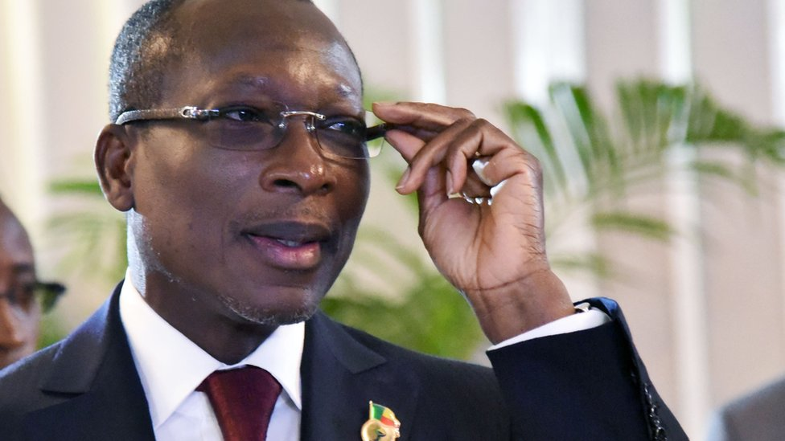image copyrightGetty Images

Businessman Patrice Talon, known as the "king of cotton", won the 2016 presidential election in a run-off vote in March.

He beat Prime Minister Lionel Zinsou, the candidate of the ruling party, who had the backing of outgoing President Boni Yayi.

Mr Talon was formerly a close ally of the outgoing president, and financed his campaigns for the 2006 and 2011 elections.

He fled to France after being accused of involvement in a plot to poison Mr Boni Yayi in 2012 - an allegation he strongly denies.

Mr Talon received a presidential pardon in May 2014 and returned from exile in October 2015.

On taking up his post in April 2016, he pledged to make tackling terrorism and cross-border crime a priority area, and to strive to promote national unity.

His proposal to limit the presidential mandate to a single five-year term was subsequently defeated in parliament.

His plans for free-market reforms have met resistance, including a series of public sector strikes.

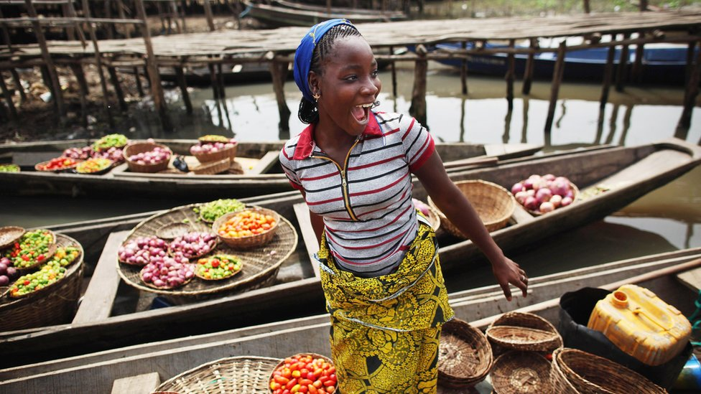image copyrightGetty Images

With dozens of private and state-owned radio and TV stations and around 60 newspapers, Benin has one of the region's most diverse media landscapes.

Around 32% of citizens are online. Facebook is the top social media platform.

# Benin profile - Timeline

Published

29 April 2019

**A chronology of key events:**

**1946** - Dahomey becomes an overseas territory of France.

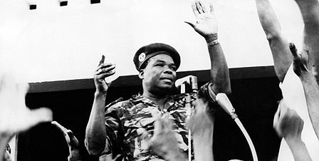image copyrightGetty Images

image captionArmy chief Christophe Soglo led a coup not long after independence. He deposed another leader a few years later

**1958** - Dahomey becomes self-governing, within the French Community.

## Independence

**1960** - Dahomey gains independence and is admitted to the UN.

**1960** - Elections won by the Parti Dahomeen de L'Unite. Party leader Hubert Maga becomes country's first president.

**1963** - President Maga is deposed in a coup led by the army's Chief of Staff, Colonel Christophe Soglo.

**1964** - Sourou-Migan Apithy is elected president.

**1965** - General Soglo forces the president to step down and a provisional government is formed. In December he assumes power.

**1967** - Major Maurice Kouandete leads a coup. Lt Col Alphonse Alley replaces Gen Soglo as head of state.

**1968** - The military regime nominates Dr Emile-Derlin Zinsou as president.

**1969** - Lt Col Kouandete deposes President Zinsou.

**1970** - Presidential elections are held but abandoned. Power is ceded to a presidential council consisting of Ahomadegbe, Apithy and Maga, who received almost equal support in the abandoned poll. Maga is the first of the three to serve as president with a two-year term.

**1972** - Ahomadegbe assumes the presidency from Maga for the next two-year term.

**1972** - Socialist Major Mathieu Kerekou seizes power; the presidential council members are detained.

## Dahomey becomes Benin

**1975** - November - Dahomey is renamed the People's Republic of Benin.

**1975** - The Marxist People's Revolutionary Party is made the country's sole political party.

**1980** - Parliament unanimously elects sole contender Mr Kerekou as president.

**1981** - Members of the former presidential council are released from house arrest.

**1984** - Parliament increases the terms of the president and MPs ("people's commissioners") from three to five years. The number of commissioners is reduced from 336 to 196.

**1988** - Two unsuccessful coup attempts.

**1989** - Benin agrees to IMF and World Bank economic adjustment measures.

**1989** - President Kerekou re-elected for a third term, drops Marxism as Benin's official ideology. Anti-government strikes and demonstrations take place.

## Constitutional changes

**1990** - Unrest continues. President Kerekou meets dissident leaders. Agreement on constitutional reform and multi-candidate presidential elections is reached.

**1991** February - Legislative elections: No party secures an overall majority. The largest grouping is an alliance of pro-Soglo parties.

**1991** March - President Kerekou is beaten by Nicephore Soglo in the first multi-candidate presidential elections. Kerekou is granted immunity from prosecution over actions taken since October 1972.

**1995** - Legislative elections sees pro-Soglo liberal Renaissance Party form the new government.

**1996** - Following accusations of irregularities in presidential elections, the constitutional court returns Mr Kerekou to office.

**1999** - Legislative elections sees coalition government formed by 10 parties.

## Kerekou re-elected

**2001** March - Mr Kerekou re-elected president.

**2002** December - First local elections since the end of the single-party regime more than 10 years earlier.

**2003** March - Legislative elections: Parties supporting President Kerekou win 52 of the 83 elective seats.

**2005** July - International Court of Justice awards most of the river islands along the disputed Benin-Niger border to Niger.

**2006** March - Political newcomer Yayi Boni, running as an independent, wins the run-off vote in presidential elections. President Kerekou is barred from the poll under a constitutional age limit.

**2006** April - World Bank and the African Development Bank approve debt relief for several countries including Benin

**2007** April - President Yayi's coalition wins control of parliament in elections.

**2008** April - Parties allied with President Yayi win a majority of local council seats nationwide, but the major cities in the south are all won by opposition parties.

## Oil discovered

**2009** February - Benin announces discovery of "significant quantities" of oil offshore near Seme, a town on the Nigeria-Benin border.

**2011** March - President Yayi is re-elected. His main challenger, Adrien Houngbedji, alleges widespread fraud

**2011** May - President Yayi's party and its allies regain control of parliament in elections.

**2015** May - President Yayi's party loses parliamentary majority in elections.

**2016** March - Businessman Patrice Talon is elected president, defeating outgoing President Boni Yayi's candidate, Prime Minister Lionel Zinsou.

**2017** April - Parliament narrowly rejects President Talon's proposal to to restrict his successors to a single six-year term, which he said would reduce "presidential complacency".

**2019** April - Parliamentary elections marked by low turnout, as all opposition parties are banned from standing due to technicalities.

Reports said several people were killed and scores injured in pre-poll violence in opposition strongholds in northern and eastern parts of the country.